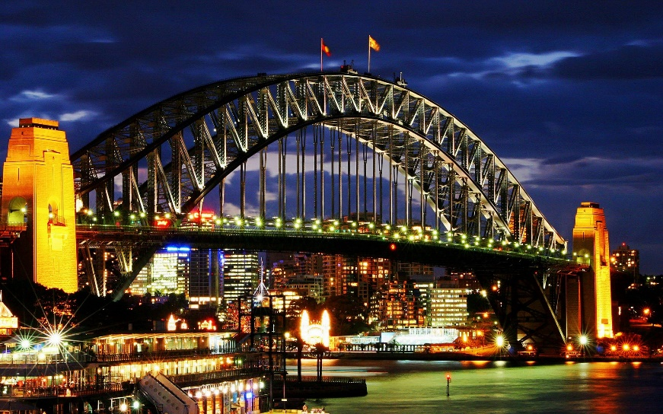

Materials Used: Concrete, Steel, Corrosion, Cable Sockets and Rivets

Construction Method Used: Arch

What it is used for? It is used for cars to cross the Sydney harbour without going through a tunnel or around.

Advantages: It is arched so that it can be stronger and support lots more cars than a smaller bridge

Disadvantages: It’s not very high so larger boats can’t fit under it

Cost: $13,500,000

Age: 82

**Sydney Harbour Bridge**

Description:

Length: 1,149m

Width: 49m

Height: 134m